Transaction Reconciliation Engine

Submitted by
Rahul Sadare 2SD22AI043

Under the Guidance and Co-Ordination of
Prof. Leena Sakri

8th Semester B.E, AIML Academic Year: 2025-26

Department of Artificial Intelligence and Machine Learning

SHRI DHARMASTHALA MANJUNATHESHWARA COLLEGE
OF ENGINEERING & TECHNOLOGY

(An Autonomous college under Visvesvaraya Technological University, Belgaum-590018 & Recognized by AICTE)
Dharwad, Karnataka, India

SDM College of Engineering and Technology,
Dharwad – 580002
Department of Artificial Intelligence and Machine Learning

CERTIFICATE
This is to certify that the project work entitled “Transaction Reconciliation Engine” is a bona fide work carried out by Mr. Rahul Sadare bearing USN: 2SD22AI043, in successfully completing the internship project (22UAIL801) at “Infosys” for 8th Semester B.E Degree in Artificial Intelligence and Machine Learning of SDM College of Engineering & Technology, Autonomous Institution under Visvesvaraya Technological University, Belgaum during the academic year 2025–2026. It is certified that all necessary suggestions indicated for internal assessment have been incorporated in the report deposited in the department library. The project work has been approved as it has successfully satisfied the academic requirements prescribed for the Bachelor of Engineering Degree.
Prof. Prashanth A | Dr. Leena I Sakri | Dr. S R Biradar | Dr. Ramesh L Chakrasali
Project Guide | Co-ordinator | HOD AIML | Principal

 | Examiner I | Examiner II
Signature with Date
Name

PREFACE
In today’s digital financial ecosystem, large numbers of transactions are processed continuously through payment gateways, banking platforms, and internal ledger systems. Maintaining consistency between these systems is a major challenge in financial operations. The internship project titled “Transaction Reconciliation Engine” was developed to automate the reconciliation process between gateway transaction records and internal banking logs.
The project was carried out during my internship at Infosys, where I designed and implemented a reconciliation platform capable of detecting mismatches, missing records, amount inconsistencies, out-of-order transactions, and unusually large transactions. The system was developed using technologies such as Flask, MySQL, PySpark, and CSV-based processing, along with rollback and audit support features.
The development process followed the Agile Scrum methodology, involving sprint planning, implementation cycles, testing, backlog management, and review discussions. The project also included dashboard-oriented analytical reporting to monitor reconciliation statistics, rollback trends, suspicious transaction patterns, and operational transaction insights effectively.
This internship provided valuable practical exposure to backend development, database management, distributed data processing, transaction auditing, and reporting workflows. It also improved my understanding of real-time financial systems, scalable reconciliation mechanisms, and enterprise application development practices. I sincerely thank Dr. Leena I Sakri for her guidance and support throughout the project, and Infosys for providing me with the opportunity to work on an industry-oriented application.

ABSTRACT

The Transaction Reconciliation Engine is a financial transaction monitoring and reconciliation system developed during the internship at Infosys. The main objective of the project is to automate the reconciliation process between gateway transaction logs and internal transaction records to identify inconsistencies, missing entries, and transaction failures efficiently.
The system was developed using Python Flask for backend services, MySQL for database management, and PySpark for scalable reconciliation processing and anomaly detection. The application supports reconciliation using both direct database records and uploaded CSV files. The system classifies transactions into categories such as MATCH, MISMATCH, AMOUNT_MISMATCH, MISSING_INTERNAL, OUT_OF_ORDER, and LARGE_TRANSACTION.
The project also implements rollback handling, transaction auditing, reconciliation job tracking, and dashboard-ready analytical reporting features. Large-value transaction detection and out-of-order transaction monitoring were integrated to improve operational visibility and suspicious transaction analysis.
The project was developed following the Agile Scrum methodology, including sprint planning, implementation, testing, and review phases. This internship helped in gaining practical exposure to financial systems, distributed data processing, backend development, reconciliation workflows, and dashboard-oriented analytics.

ACKNOWLEDGEMENT

I express my sincere gratitude to our Principal, Dr. Ramesh L Chakrasali, and the Department of Artificial Intelligence and Machine Learning of SDM College of Engineering & Technology, Dharwad, for providing the facilities, encouragement, and academic support required for completing the internship project successfully.
I would like to convey my heartfelt thanks to the Head of the Department, Dr. S R Biradar, for his continuous encouragement, valuable suggestions, and support throughout the internship duration.
I express my deep sense of gratitude to my project guide and co-ordinator, Dr. Leena I Sakri, for her constant guidance, motivation, constructive feedback, and technical support during every phase of the project development. Her valuable suggestions and encouragement helped me improve both my technical and analytical skills throughout the internship.
I also extend my sincere thanks to Infosys for providing me with the opportunity to work on an industry-oriented project and gain practical exposure to backend development, reconciliation systems, distributed data processing, dashboard analytics, and Agile Scrum methodologies using modern technologies.
I would also like to thank all the teaching and non-teaching staff members of the department for their support and co-operation during the internship period.
Finally, I would like to express my gratitude to my parents, friends, and well-wishers for their constant support, encouragement, and motivation throughout the successful completion of the internship project.

Project Member
Rahul Sadare (2SD22AI043)

LIST OF FIGURES
Chapter No | Title | Page No
Figure 4.1 | System Architecture Diagram | 19
Figure 4.2 | Data Flow Diagram | 22
Figure 4.3  Figure 7.1  Figure 7.2  Figure 7.3  Figure 7.4  Figure 7.5  Figure 7.6  Figure 7.7 | Reconciliation Workflow Diagram  Transaction Processing Interface  New Transaction Processing Page  Reconciliation Input Selection Interface  Database Reconciliation Processing  Reconciliation Results  Reconciliation Summary Dashboard  Transaction Summary Dashboard | 26  47  47  48  49  49  51  52

LIST OF TABLES
Chapter No | Title | Page No
Table 2.1 | Development Environment and System Configuration | 8
Table 7.1 | Reconciliation Output Summary | 42

TABLE OF CONTENTS
PREFACE |  | i
ABSTRACT |  | ii
ACKNOWLEDGEMENT |  | iii
LIST OF FIGURES |  | iv
LIST OF TABLES |  | iv
Chapter No | Title | Page No
1 | INTRODUCTION | 1
 | 1.1 About the Company | 2
 | 1.2 Introduction | 3
 | 1.3 Problem Statement | 4
 | 1.4 Objectives | 4
 | 1.5 Methodology | 5
 | 1.6 Limitations | 5
2 | TECHNOLOGIES USED | 7
 | 2.1 Development Environment and System Configuration | 8
 | 2.2 Programming Languages and Frameworks | 9
 | 2.3 Database and Storage Technologies | 9
 | 2.4 Big Data and Analytical Processing | 10
 | 2.5 Web Server and Client-Server Technologies | 10
 | 2.6 Dashboard and Reporting Technologies | 11
 | 2.7 Version Control and Development Methodology | 11
3 | SOFTWARE REQUIREMENT SPECIFICATION | 13
 | 3.1 Overall Description | 14
 | 3.2 Product Perspective | 14
 | 3.3 Functional Requirements | 15
 | 3.4 Non-Functional Requirements | 15
 | 3.5 Constraints and Limitations | 16
 | 3.6 Assumptions and Dependencies | 16
4 | DESIGN PHASE | 18
 | 4.1 System Architecture | 19
 | 4.2 Data Flow Diagram | 21
 | 4.3 Client Server Model | 23
 | 4.4 Database Design | 24
 | 4.5 Reconciliation Workflow | 25
 | 4.6 Dashboard Design | 27
5 | IMPLEMENTATION PHASE | 28
 | 5.1 Transaction Processing Module | 29
 | 5.1.1 Pseudo Code for Transaction Processing | 30
 | 5.2 Reconciliation Engine | 31
 | 5.2.1 Pseudo Code for Reconciliation Engine | 32
 | 5.3 Rollback Mechanism | 33
 | 5.3.1 Pseudo Code for Rollback Mechanism | 34
 | 5.4 CSV Upload and Export Module | 35
 | 5.5 Large Transaction Detection | 35
 | 5.5.1 Pseudo Code for Large Transaction Detection | 36
 | 5.6 Out-of-Order Transaction Detection | 37
 | 5.6.1 Pseudo Code for Out-of-Order Detection | 37
 | 5.7 Dashboard and Analytics | 38
 | 5.8 Data Generation and Testing | 39
6 | TESTING PHASE | 40
 | 6.1 Testing and Quality Assurance | 41
 | 6.2 Recording the Test Cases | 42
 | 6.3 Debugging and Validation | 43
 | 6.4 Performance Evaluation | 44
7 | RESULT AND DISCUSSION | 45
 | 7.1 Transaction Processing Results | 46
 | 7.2 Reconciliation Results | 47
 | 7.3 Large Transaction Analysis | 47
 | 7.4 Out-of-Order Transaction Analysis | 48
 | 7.5 Dashboard and Analytical Reporting | 48
 | 7.6 Discussion | 49
8 | APPLICATIONS | 50
 | 8.1 Banking Systems | 51
 | 8.2 Digital Payment Gateways | 51
 | 8.3 Fraud Detection and Monitoring | 52
 | 8.4 Financial Auditing Systems | 53
 | 8.5 Enterprise Transaction Monitoring | 53
 | 8.6 Analytical Dashboard Systems | 54
9 | CONCLUSIONS | 55
10 | FUTURE SCOPE | 58
11 | REFERENCES | 61
APPENDIX A | Internship / Group Photographs | 64
APPENDIX B | Internship Completion Certificate | 65

CHAPTER 1
INTRODUCTION

INTRODUCTION

1.1 ABOUT THE COMPANY
The internship was carried out under a structured industry-oriented training program conducted by a leading multinational technology and consulting organization specializing in enterprise software solutions, analytics, cloud technologies, and digital transformation services. The organization provides technology solutions for domains such as banking, healthcare, retail, manufacturing, and financial services.
The internship program focused on practical exposure to real-time software development practices, agile methodologies, backend development, database management, distributed processing systems, and analytical reporting workflows. Students were introduced to enterprise development standards, sprint-based implementation, collaborative project execution, and modern technology stacks.
During the internship period, technical learning sessions and project implementation activities were carried out systematically through sprint planning, backlog management, implementation phases, debugging activities, and review discussions. The internship environment encouraged teamwork, problem-solving, documentation practices, and version control workflows.
The project assigned during the internship focused on developing an automated transaction reconciliation platform capable of comparing gateway transaction records with internal transaction logs and identifying inconsistencies automatically. The project involved transaction monitoring, rollback handling, anomaly detection, dashboard reporting, and scalable reconciliation processing using modern technologies such as Flask, MySQL, PySpark, GitHub, and CSV-based data processing systems.
This internship experience provided valuable exposure to enterprise software engineering practices, financial transaction systems, reconciliation workflows, backend application development, and analytical dashboard concepts while improving technical and professional skills required in real-world software development environments.

1.2 INTRODUCTION
In modern financial systems, millions of transactions are processed daily through payment gateways, banking platforms, and internal ledger systems. Maintaining consistency between gateway transaction records and internal banking logs is a major challenge for financial institutions. Transaction inconsistencies may lead to settlement failures, delayed refunds, duplicate processing, and operational risks.
The project developed during the internship focuses on building an automated Transaction Reconciliation System capable of comparing gateway transaction logs with internal transaction records and identifying mismatches efficiently. The system was designed to detect missing transactions, amount mismatches, failed transactions, out-of-order transaction sequences, and suspicious large-value transactions.
The system was implemented using Flask for backend development, MySQL for database management, and Apache Spark (PySpark) for scalable reconciliation processing and anomaly detection. The application supports both database-based reconciliation and CSV-based reconciliation workflows. Additional features such as rollback handling, audit logging, reconciliation job tracking, and dashboard-oriented reporting were also implemented.
The reconciliation engine compares gateway transaction records with internal debit and credit ledger entries and classifies transactions into categories such as:
- MATCH
- MISMATCH
- MISSING_INTERNAL
- AMOUNT_MISMATCH
- OUT_OF_ORDER
- LARGE_TRANSACTION
The project also includes analytical dashboard concepts for monitoring reconciliation statistics, rollback activities, transaction trends, and operational insights. The development process followed the Agile Scrum methodology involving sprint planning, implementation cycles, debugging, testing, and review meetings throughout the internship period.
The internship provided practical exposure to backend application development, database operations, distributed data processing, financial transaction workflows, and dashboard-oriented analytical systems while improving software engineering and problem-solving skills.
1.3 PROBLEM STATEMENT
Financial institutions and payment processing systems handle large volumes of digital transactions every day through multiple gateway systems and internal banking platforms. Maintaining consistency between external gateway records and internal transaction logs is a major operational challenge.
Manual reconciliation processes are time-consuming, error-prone, and inefficient when handling large datasets. Transaction inconsistencies such as missing entries, amount mismatches, duplicate processing, delayed settlements, and failed transactions may result in financial risks and operational inefficiencies.
The existing systems often lack automated rollback handling, anomaly detection, transaction monitoring, and analytical reporting capabilities. There is a need for an automated reconciliation system capable of identifying inconsistencies efficiently and generating operational insights for administrators.
The project aims to develop a scalable transaction reconciliation platform capable of comparing gateway transaction records with internal transaction logs, detecting anomalies automatically, handling rollback operations, and supporting dashboard-based monitoring and analytical reporting.
1.4 OBJECTIVES
The main objectives of the project are:
- To develop an automated transaction reconciliation system.
- To compare gateway transaction logs with internal transaction records.
- To identify mismatches and transaction inconsistencies automatically.
- To implement rollback handling for failed transactions.
- To detect out-of-order and large-value transactions.
- To support scalable reconciliation processing using Apache Spark.
- To provide CSV-based and database-based reconciliation support.
- To generate dashboard-oriented reconciliation reports and analytics.
- To improve transaction monitoring and operational visibility.

1.5 METHODOLOGY
The project development followed the Agile Scrum methodology, which supports iterative development, sprint-based execution, continuous testing, and collaborative project management.
The project implementation process included:
- Requirement Analysis
- Database Design
- Backend Development
- Transaction Processing Module Development
- Reconciliation Engine Implementation
- Spark-Based Data Processing
- Rollback Mechanism Implementation
- CSV Upload and Export Integration
- Dashboard and Reporting Design
- Testing and Validation
The system was developed in multiple sprint cycles involving sprint planning, task allocation, debugging, testing, review meetings, and feature enhancements. GitHub was used for version control and collaborative development activities.
Apache Spark was integrated to support scalable reconciliation and anomaly detection for large transaction datasets. The system also utilized MySQL for structured transaction storage and Flask for backend API and application workflow management.
1.6 LIMITATIONS
The project has the following limitations:
- The system currently operates on batch-based reconciliation workflows.
- Real-time streaming reconciliation is not implemented.
- Dashboard integration is limited to analytical reporting concepts.
- Fraud detection is rule-based and does not include AI/ML models.
Despite these limitations, the system successfully demonstrates scalable transaction reconciliation, rollback handling, anomaly detection, and operational monitoring workflows suitable for financial transaction systems.

CHAPTER 2
TECHNOLOGIES USED

TECHNOLOGIES USED
2.1 DEVELOPMENT ENVIRONMENT AND SYSTEM CONFIGURATION
The project was developed and tested using a software-oriented environment capable of supporting backend application development, database management, distributed data processing, and analytical dashboard generation. Since the project focuses on transaction reconciliation and financial analytics, no embedded systems or hardware components were used.
The development environment included tools required for Flask application development, MySQL database operations, Apache Spark execution, CSV processing, and dashboard preparation.

Table 2.1 - Development Environment and System Configuration
Component | Specification
Processor | Intel Core i5 / Equivalent
RAM | 8 GB or Higher
Storage | 256 GB SSD / HDD
Operating System | Windows 10 / Windows 11
IDE Used | Visual Studio Code
Database | MySQL
Backend Framework | Flask
Big Data Framework | Apache Spark (PySpark)
Version Control | GitHub

The configured environment supported transaction processing, reconciliation workflows, dashboard analytics, CSV-based processing, and distributed reconciliation execution efficiently.

2.2 PROGRAMMING LANGUAGES AND FRAMEWORKS
Python was used as the primary programming language for backend development, reconciliation processing, rollback handling, CSV workflows, and database interaction.
Flask was used as the backend web framework for:
- Route management
- Transaction execution
- CSV upload handling
- Reconciliation workflows
- Dashboard rendering
Apache Spark (PySpark) was integrated for scalable reconciliation processing and anomaly detection using large transaction datasets.
MySQL Connector was used for database communication and SQL query execution.
Pandas was used for CSV handling, data formatting, and preprocessing operations during reconciliation workflows.
HTML and CSS were used for frontend interface development including dashboard pages, transaction forms, reconciliation pages, and reporting modules.
2.3 DATABASE AND STORAGE TECHNOLOGIES
MySQL was used as the primary relational database management system for storing transaction records, reconciliation outputs, rollback information, and audit logs.
The major database tables implemented in the project include:
- accounts
- gateway_txn
- transaction_log
- gateway_logs
- reconciliation
- reconciliation_jobs
- large_transaction_audit
The database schema was designed to maintain transaction consistency, structured storage, and efficient reconciliation processing.
CSV-based storage and export workflows were also implemented for dashboard integration and analytical reporting.
2.4 BIG DATA AND ANALYTICAL PROCESSING
Apache Spark was integrated into the project to support scalable reconciliation and anomaly detection workflows.
Spark was mainly used for:
- Transaction aggregation
- Batch reconciliation
- Large dataset processing
- Out-of-order transaction detection
- Large transaction analysis
Spark improved reconciliation efficiency and enabled scalable processing of transaction datasets generated during the internship project.
The processed datasets were also prepared for dashboard analytics and reporting workflows.
2.5 WEB SERVER AND CLIENT-SERVER TECHNOLOGIES
The application follows a client-server architecture where users interact with frontend pages while backend services process reconciliation workflows and transaction operations.
The Flask backend handled:
- User requests
- Transaction processing
- Database interaction
- CSV upload processing
- Dashboard result generation
The frontend interface was developed using HTML and CSS to provide user-friendly access to transaction workflows and reconciliation monitoring.
The backend communicates with:
- MySQL database
- Apache Spark engine
- CSV processing modules
This architecture improved modularity and workflow organization.
2.6 DASHBOARD AND REPORTING TECHNOLOGIES
The project supports dashboard-oriented analytical reporting and reconciliation monitoring using exported transaction datasets.
Dashboard workflows were designed for:
- Transaction trend analysis
- Failure monitoring
- Rollback statistics
- Bank-wise analytics
- Operational monitoring
Power BI concepts were utilized for preparing dashboard-compatible datasets and analytical visualization workflows.
The exported CSV files can be integrated with Power BI dashboards for operational reporting and reconciliation analytics.
2.7 VERSION CONTROL AND DEVELOPMENT METHODOLOGY
GitHub was used throughout the project for version control, sprint tracking, collaborative development, and backup management.
The project followed Agile Scrum methodology involving:
- Sprint planning
- Backlog grooming
- Task allocation
- Sprint reviews
- Testing and debugging
The development process was divided into:
- Sprint 0 — Planning and Requirement Analysis
- Sprint 1 — Core Reconciliation System Development
- Sprint 2 — Dashboard Analytics and Data Transformation
The Scrum methodology helped in managing implementation workflows, tracking progress, and improving development efficiency.

CHAPTER 3
SOFTWARE REQUIREMENT SPECIFICATION

3.1 OVERALL DESCRIPTION
The Transaction Reconciliation System is a backend-driven financial transaction monitoring platform developed to automate the reconciliation process between gateway transaction records and internal transaction logs. The system identifies mismatches, missing records, amount inconsistencies, large-value transactions, and out-of-order events while supporting rollback and audit functionalities.
The application was developed using Flask, MySQL, and Apache Spark to support scalable reconciliation workflows and analytical reporting. The system supports both database-based and CSV-based reconciliation mechanisms.
The project simulates enterprise-level reconciliation workflows commonly used in banking systems and payment gateway infrastructures.
3.2 PRODUCT PERSPECTIVE
The system acts as an independent reconciliation platform capable of comparing gateway transaction records with internal transaction logs.
The application integrates:
- Backend transaction processing
- Database-driven reconciliation
- Spark-based anomaly detection
- Rollback handling
- CSV upload and export workflows
- Dashboard-oriented reporting
The architecture follows a client-server model where users interact with frontend interfaces while backend services process reconciliation workflows and store results in the database.
The project was designed with scalability in mind and can be extended further for enterprise deployment and advanced analytical processing.

3.3 FUNCTIONAL REQUIREMENTS
The major functions implemented in the system are:
Transaction Processing
- Create gateway transactions
- Validate account balances
- Generate debit and credit entries
Reconciliation Engine
- Compare gateway logs with internal transaction records
- Detect mismatches and inconsistencies
- Generate reconciliation classifications
Rollback Handling
- Reverse failed transactions
- Restore account balances
- Update transaction statuses
CSV Processing
- Upload reconciliation CSV files
- Process exported transaction datasets
- Generate analytical reports
Dashboard Reporting
- Display reconciliation statistics
- Monitor transaction trends
- Show rollback and anomaly reports
3.4 NON-FUNCTIONAL REQUIREMENTS
The system was designed to satisfy the following non-functional requirements:

Reliability
The system maintains transaction consistency using transaction logs, rollback handling, and audit mechanisms.
Scalability
Apache Spark integration supports large transaction dataset processing and scalable reconciliation execution.
Maintainability
The project follows modular coding practices for easier debugging and future enhancements.
Usability
The application provides user-friendly interfaces for transaction creation, reconciliation execution, and dashboard monitoring.
Performance
The system supports efficient transaction processing and reconciliation workflows with minimal processing delay.
3.5 CONSTRAINTS AND LIMITATIONS
The project has the following limitations:
- Supports batch-based reconciliation workflows only
- Real-time streaming reconciliation is not implemented
- Dashboard integration is limited to analytical reporting workflows
- Distributed Spark cluster deployment is not implemented
- The project operates in a locally configured environment
These limitations were considered during implementation to maintain focus on core reconciliation functionalities.
3.6 ASSUMPTIONS AND DEPENDENCIES
The system implementation is based on the following assumptions:
- Transaction records follow a structured format
- Database connectivity remains active during reconciliation
- Apache Spark environment is configured properly
- Uploaded CSV files contain valid transaction data
- Transaction logs contain valid timestamps and identifiers
The project depends on:
- Python runtime environment
- Flask framework
- MySQL database
- Apache Spark (PySpark)
- CSV processing libraries
- GitHub version control

CHAPTER 4
DESIGN PHASE

4.1 SYSTEM ARCHITECTURE
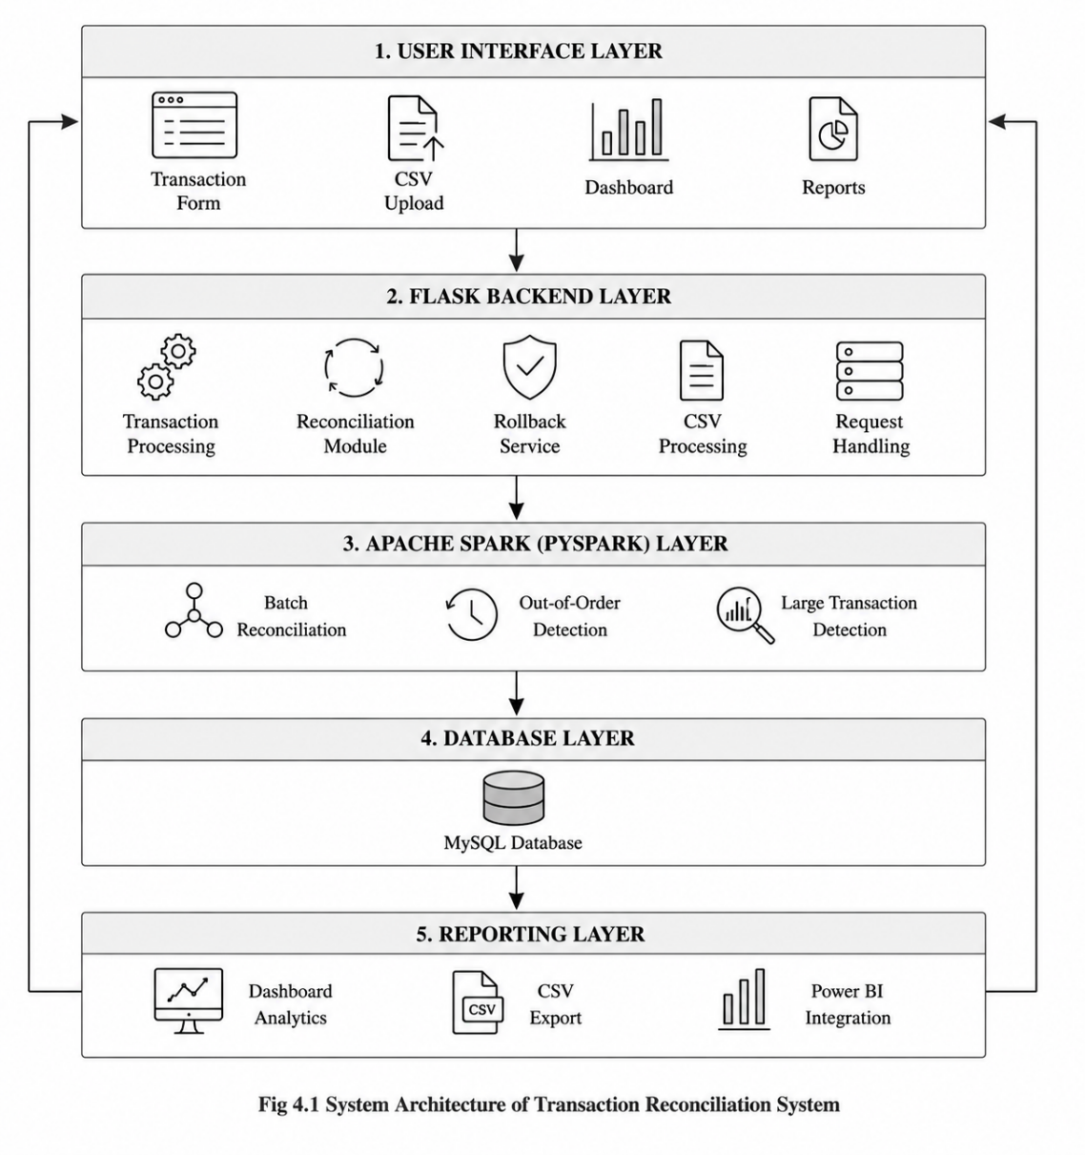
The Transaction Reconciliation System follows a layered client-server architecture designed to support transaction processing, reconciliation execution, rollback handling, CSV processing, and dashboard-oriented reporting.
Figure 4.1: System Architecture Diagram
The architecture consists of the following layers:
User Interface Layer
The User Interface Layer allows users to interact with the system through:
- Transaction Form
- CSV Upload
- Dashboard
- Reports
This layer provides interfaces for transaction processing, reconciliation execution, dashboard monitoring, and report viewing.
Flask Backend Layer
The Flask Backend Layer handles the core application functionalities including:
- Transaction Processing
- Reconciliation Module
- Rollback Service
- CSV Processing
- Request Handling
This layer manages backend workflows, user requests, database communication, and reconciliation operations.
Apache Spark (PySpark) Layer
The Apache Spark (PySpark) Layer is responsible for scalable transaction processing and analytical reconciliation operations.
This layer performs:
- Batch Reconciliation
- Out-of-Order Detection
- Large Transaction Detection
Spark improves processing efficiency and supports reconciliation of large transaction datasets.
Database Layer
The Database Layer uses MySQL for storing and managing transaction-related data.
The database maintains:
- Transaction records
- Reconciliation results
- Rollback details
- Audit logs
This layer ensures structured data storage and consistency throughout reconciliation workflows.
Reporting Layer
The Reporting Layer generates analytical outputs and dashboard visualizations including:
- Dashboard Analytics
- CSV Export
- Power BI Integration
This layer supports reporting, monitoring, and visualization of reconciliation activities and transaction analytics.
4.2 DATA FLOW DIAGRAM
The Data Flow Diagram (DFD) represents the movement of transaction data between different modules of the Transaction Reconciliation System. The diagram illustrates how user requests, transaction records, reconciliation operations, and analytical reports flow through the system components.
The Level-1 DFD mainly consists of the following processes:
- Transaction Creation (P1)
Handles transaction form input from the user and stores transaction details in the MySQL database.
- CSV Upload (P2)
Accepts CSV transaction files from the user and performs bulk insertion of transaction data into the database.
- Rollback Processing (P3)
Handles rollback requests and updates transaction records by reverting incorrect or failed transactions.
- Reconciliation (P4)
Fetches transaction logs from the database and submits reconciliation jobs to the Apache Spark engine for processing and anomaly detection.
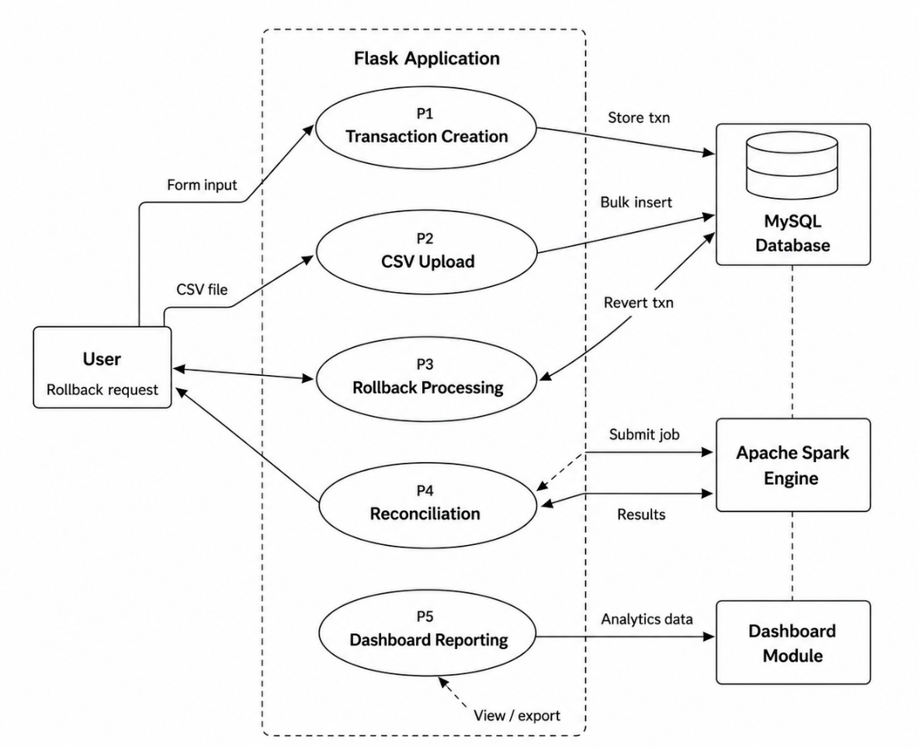
- Dashboard Reporting (P5)
Generates analytical data and sends processed transaction information to the dashboard module for visualization and reporting.
Fig 4.2 Data Flow Diagram
The DFD also represents interactions between:
- User and Flask Application
- Flask Application and MySQL Database
- Flask Application and Apache Spark Engine
- Dashboard Reporting and Dashboard Module
The diagram helps in understanding:
- Transaction data movement
- Reconciliation workflow execution
- Database communication
- Spark processing integration
- Rollback handling process
- Dashboard analytics workflow
Both Level 0 and Level 1 DFDs were designed to provide a clear representation of the overall system workflow and detailed transaction reconciliation operations.
4.3 CLIENT SERVER MODEL
The application follows a client-server architecture where users interact with frontend pages while backend services process transactions and reconciliation workflows.
Client Side
The client side includes:
- Transaction forms
- CSV upload interfaces
- Dashboard result pages
- Export modules
Users perform activities such as:
- Creating transactions
- Running reconciliation
- Uploading transaction datasets
- Viewing reconciliation results
Server Side
The server side was developed using Flask and handles:
- Request processing
- Database communication
- Reconciliation execution
- CSV processing
- Dashboard rendering
The server communicates with:
- MySQL database
- Apache Spark engine
- CSV processing modules
This architecture improves workflow organization and scalability.
4.4 DATABASE DESIGN
The database design was implemented using MySQL and contains multiple relational tables for transaction processing, reconciliation workflows, rollback tracking, and audit management.
Major Tables
accounts
Stores customer account details and balances.
gateway_txn
Stores gateway-side transaction records.
transaction_log
Stores internal debit and credit entries.
gateway_logs
Maintains gateway transaction logs and statuses.
reconciliation
Stores reconciliation classifications and results.
reconciliation_jobs
Tracks reconciliation execution jobs.
large_transaction_audit
Stores suspicious large-value transaction details.
The database schema was normalized to maintain consistency and efficient reconciliation processing.
4.5 RECONCILIATION WORKFLOW
The reconciliation workflow is responsible for comparing gateway transaction records with internal transaction logs and automatically identifying inconsistencies within the transaction processing system. The workflow was implemented using Apache Spark (PySpark) to support scalable reconciliation and anomaly detection operations.
The reconciliation process begins by fetching gateway transaction logs followed by internal transaction records from the MySQL database. The Spark reconciliation engine then executes batch reconciliation operations and compares transaction entries based on transaction identifiers, transaction amounts, timestamps, and processing status.
The workflow performs multiple validation checks including:
- Transaction matching
- Out-of-order transaction detection
- Large transaction detection
- Mismatch identification
- Rollback validation
The major workflow steps are:
- Fetch gateway transaction logs
- Fetch internal transaction logs
- Execute Spark reconciliation batch job
- Compare transaction entries
- Verify transaction match status
- Detect out-of-order transactions
- Detect large transactions
- Generate reconciliation results
- Validate rollback requirement
- Trigger rollback if required
- Store reconciliation results in MySQL
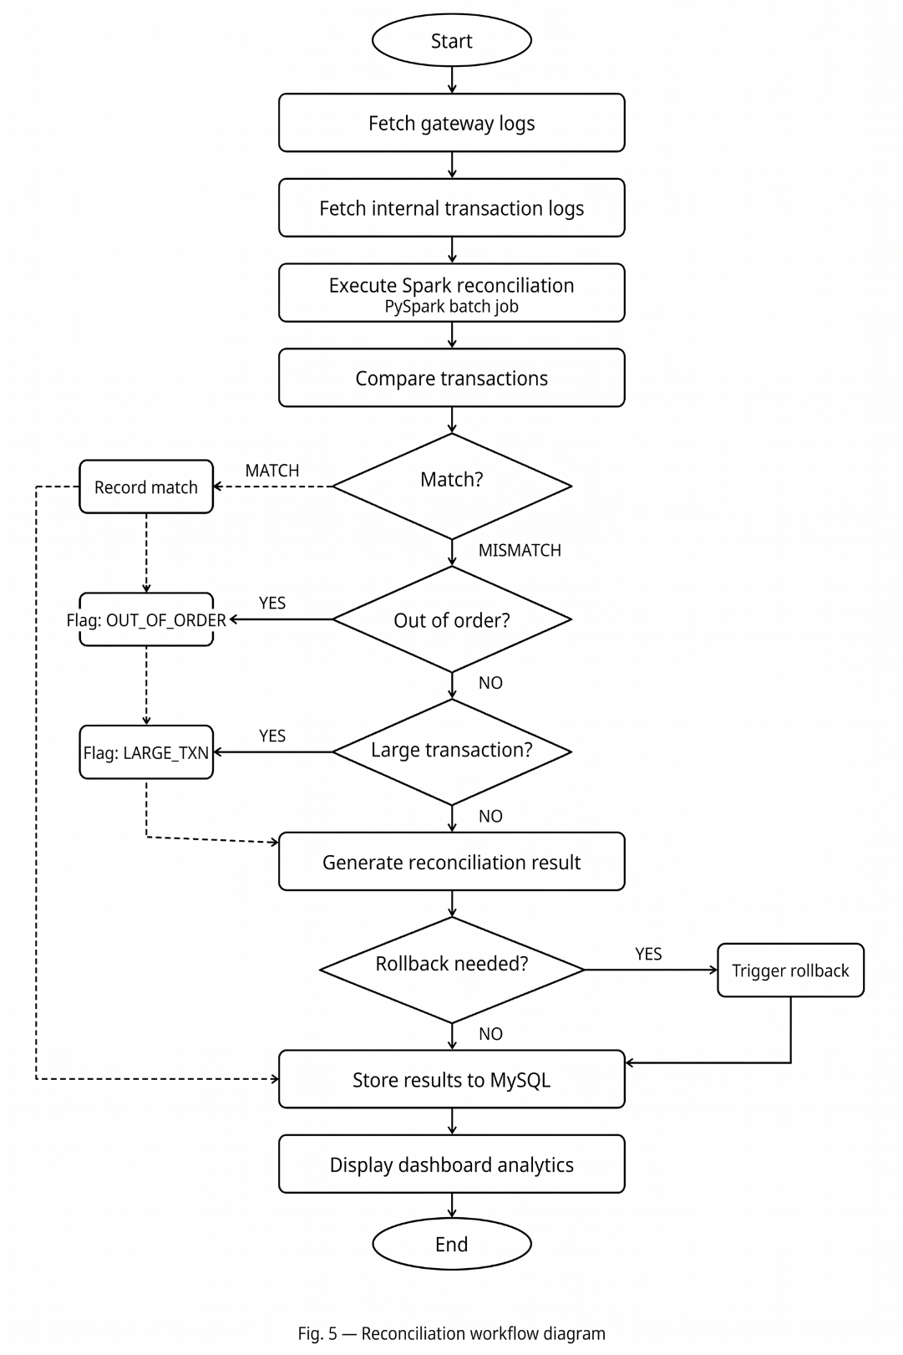
- Display dashboard analytics and reports
Fig 4.3 Reconciliation Workflow Diagram
The workflow classifies transactions into multiple reconciliation result categories including:
- MATCH
- MISMATCH
- OUT_OF_ORDER
- LARGE_TRANSACTION
If reconciliation identifies inconsistencies or rollback conditions, the system triggers rollback operations and updates transaction records accordingly. All reconciliation results are stored in the MySQL database and are later used for dashboard analytics and reporting.
The reconciliation workflow improves:
- Transaction monitoring
- Reconciliation accuracy
- Operational visibility
- Fraud and anomaly detection
- Automated rollback handling
- Analytical reporting efficiency
4.6 DASHBOARD DESIGN
The dashboard module was designed to provide analytical visualization and operational monitoring for reconciliation activities and transaction statistics.
The dashboard displays:
- Transaction trends
- Failure statistics
- Rollback summaries
- Bank-wise analytics
- Large transaction reports
- Out-of-order transaction analysis
The generated reconciliation datasets were structured to support Power BI integration and dashboard visualization workflows.
The dashboard improves operational monitoring and reconciliation analysis through graphical reporting and transaction filtering features.

CHAPTER 5
IMPLEMENTATION PHASE

5.1 TRANSACTION PROCESSING MODULE
The transaction processing module is responsible for creating and managing financial transactions within the reconciliation system. The module validates account details, verifies sender balances, generates transaction records, and stores gateway transaction logs for reconciliation processing.
When a user initiates a transaction through the web interface, the backend application validates the sender and receiver accounts before processing the transaction. If sufficient balance is available, the system generates:
- Gateway transaction records
- Debit transaction entries
- Credit transaction entries
- Gateway processing logs
- Audit entries for reconciliation tracking
- Timestamp-based transaction references
The module supports transaction statuses such as:
- SUCCESS
- FAILED
- PENDING
- ROLLEDBACK
- PROCESSING
The module also performs:
- Account balance verification
- Transaction timestamp generation
- Gateway status management
- Internal transaction logging
- Database consistency validation
This module forms the foundation of the reconciliation workflow and ensures transaction consistency during processing.
5.1.1 PSEUDO CODE FOR TRANSACTION PROCESSING
START

FETCH sender account
FETCH receiver account

IF sender balance < amount
MARK transaction as FAILED
ELSE
CREATE gateway transaction
INSERT debit entry
INSERT credit entry
UPDATE balances
MARK transaction as SUCCESS
END IF

STORE gateway log

END

5.2 RECONCILIATION ENGINE
The reconciliation engine is the core module of the project responsible for comparing gateway transaction records with internal transaction logs and identifying inconsistencies automatically.
The reconciliation process was implemented using Apache Spark (PySpark) to support scalable processing of large transaction datasets. The engine compares:
- Transaction amounts
- Transaction statuses
- Internal transaction entries
- Processing timestamps
- Gateway transaction identifiers
- Ledger consistency
The reconciliation engine classifies transactions into:
- MATCH
- MISMATCH
- MISSING_INTERNAL
- AMOUNT_MISMATCH
- OUT_OF_ORDER
- LARGE_TRANSACTION
The reconciliation engine also performs:
- Batch transaction analysis
- Spark-based aggregation
- Transaction grouping
- Timestamp validation
- Audit record generation
The generated reconciliation results are stored in the database and displayed through dashboard reports.

5.2.1 PSEUDO CODE FOR RECONCILIATION ENGINE
START

LOAD gateway logs
LOAD internal transaction logs

GROUP transactions BY transaction_id

FOR each transaction
COMPARE amount
COMPARE status
CHECK transaction existence

IF amounts mismatch
MARK as AMOUNT_MISMATCH

ELSE IF internal record missing
MARK as MISSING_INTERNAL

ELSE IF timestamp out of order
MARK as OUT_OF_ORDER

ELSE IF amount > threshold
MARK as LARGE_TRANSACTION

ELSE
MARK as MATCH
END FOR

STORE reconciliation results

END

5.3 ROLLBACK MECHANISM
The rollback mechanism was implemented to maintain transaction consistency whenever reconciliation detects mismatches or failed transactions.
Rollback operations reverse incorrect transactions by:
- Restoring sender balances
- Reversing credit entries
- Updating transaction statuses
- Maintaining rollback audit records
- Logging rollback timestamps
- Preventing duplicate rollback operations
Whenever reconciliation detects inconsistencies, the rollback mechanism restores the transaction state and updates the transaction status to ROLLEDBACK.
The rollback system improves:
- Financial consistency
- Transaction reliability
- Error recovery
- Audit traceability

5.3.1 PSEUDO CODE FOR ROLLBACK MECHANISM
START

FETCH transaction details

FOR each debit entry
RESTORE sender balance

FOR each credit entry
DEDUCT receiver balance

UPDATE transaction status to ROLLEDBACK

STORE rollback details

END
5.4 CSV UPLOAD AND EXPORT MODULE
The system supports CSV-based reconciliation workflows to process external transaction datasets and generate analytical reports.
The CSV module supports:
- Gateway log uploads
- Internal transaction log uploads
- CSV validation
- Reconciliation execution
- CSV export generation
- Dashboard dataset preparation
The export functionality allows administrators to download:
- Gateway logs
- Transaction logs
- Reconciliation reports
- Dashboard-ready datasets
- Analytical transaction summaries
The module also performs:
- CSV schema validation
- File integrity verification
- Data preprocessing
- Structured export generation
CSV exports were structured to support Power BI dashboard integration and analytical reporting workflows.
5.5 LARGE TRANSACTION DETECTION
The system includes a large transaction detection module to identify high-value transactions requiring additional monitoring.
Whenever a transaction exceeds the predefined threshold amount, the system classifies it as a LARGE_TRANSACTION and stores the details in the large_transaction_audit table.
The module supports:
- Threshold comparison
- Transaction flagging
- Audit log generation
- Dashboard reporting
- Risk-based monitoring
- Suspicious transaction tracking
Large transaction monitoring improves:
- Fraud analysis
- Financial auditing
- Risk management
- Transaction monitoring efficiency

5.5.1 PSEUDO CODE FOR LARGE TRANSACTION DETECTION
START
FOR each transaction
IF amount >= threshold
MARK as LARGE_TRANSACTION
STORE audit record
END IF
END FOR

END
5.6 OUT-OF-ORDER TRANSACTION DETECTION
The system supports out-of-order transaction detection using Spark window functions and timestamp comparison mechanisms.
Out-of-order transactions occur when transaction logs arrive in an incorrect sequence compared to the expected processing order.
The detection process uses:
- Timestamp comparison
- Spark lag() window functions
- Transaction sequence analysis
- Transaction ordering validation
- Event stream monitoring
Detected transactions are classified as OUT_OF_ORDER and displayed through reconciliation dashboards and analytical reports.
The module improves:
- Event sequence monitoring
- Gateway consistency analysis
- Stream processing validation
- Transaction integrity management
5.6.1 PSEUDO CODE FOR OUT-OF-ORDER DETECTION
START
SORT transactions BY timestamp
FOR each transaction
COMPARE current timestamp with previous timestamp
IF current timestamp < previous timestamp
MARK as OUT_OF_ORDER
END IF
END FOR
END

5.7 DASHBOARD AND ANALYTICS
The project includes dashboard-oriented analytical reporting features for transaction monitoring and reconciliation analysis.
The dashboard supports:
- Transaction trend analysis
- Reconciliation statistics
- Failure monitoring
- Rollback analysis
- Bank-wise transaction analytics
- Large transaction reports
- Out-of-order transaction monitoring
- Time-based reconciliation reports
- Transaction failure distribution
The generated datasets were prepared for Power BI dashboard integration and analytical visualization workflows.
The dashboard improves:
- Operational monitoring
- Transaction visibility
- Reconciliation analysis
- Administrative reporting
- Decision-making support
- Analytical monitoring efficiency

5.8 DATA GENERATION AND TESTING
Synthetic transaction datasets were generated using Python scripts to simulate real-world transaction workflows and reconciliation scenarios.
The generated datasets included:
- Gateway transactions
- Failed transactions
- Pending transactions
- Large-value transactions
- Out-of-order transactions
- Missing internal transaction records
The generated data was used for:
- Reconciliation testing
- Spark validation
- Dashboard analytics
- Performance analysis
- Rollback verification
- Error detection testing
The datasets helped evaluate the scalability, reliability, and reconciliation accuracy of the system during implementation and testing phases.

CHAPTER 6
TESTING PHASE

6.1 TESTING AND QUALITY ASSURANCE
Testing and quality assurance were important phases during the development of the Transaction Reconciliation System. The application was tested continuously throughout the implementation process to ensure correct transaction processing, accurate reconciliation, reliable rollback handling, and proper dashboard reporting.
The testing process focused on validating:
- Transaction creation workflows
- Database operations
- Reconciliation accuracy
- Rollback execution
- CSV upload functionality
- Spark processing
- Dashboard result generation
Different types of testing were performed during the project implementation to ensure that all modules operated correctly under different transaction scenarios.
The quality assurance process also included:
- Debugging backend services
- Verifying reconciliation classifications
- Validating transaction consistency
- Monitoring database updates
- Checking dashboard outputs
Testing helped identify inconsistencies, processing issues, reconciliation mismatches, and workflow errors during development.
6.2 RECORDING THE TEST CASES
Test cases were prepared and executed to validate the correctness of individual modules and overall system workflows. The testing process verified whether the system generated expected outputs under different transaction conditions.
The following scenarios were tested:
- Successful transactions
- Failed transactions
- Pending transactions
- Amount mismatch scenarios
- Missing internal transaction records
- Large transaction detection
- Out-of-order transaction detection
- Rollback execution
- CSV upload processing
Table 7.1 - Reconciliation Output Summary
Description | Expected Result
Successful transaction | MATCH
Missing internal record | MISSING_INTERNAL
Amount mismatch | AMOUNT_MISMATCH
Large transaction | LARGE_TRANSACTION
Out-of-order transaction | OUT_OF_ORDER
Failed reconciliation | ROLLEDBACK
The test case execution process helped ensure that the reconciliation engine and rollback mechanisms functioned correctly under multiple operational conditions.
6.3 DEBUGGING AND VALIDATION
Debugging was performed throughout the development lifecycle to identify and resolve errors related to transaction processing, Spark execution, reconciliation workflows, CSV handling, and database operations.
The major debugging activities included:
- Database connectivity issues
- Spark configuration errors
- Transaction rollback inconsistencies
- CSV formatting issues
- Dashboard filtering problems
- Timestamp comparison errors
- Reconciliation duplication handling
Validation was performed to ensure:
- Correct reconciliation classifications
- Accurate balance restoration
- Proper transaction logging
- Correct Spark aggregation results
- Reliable dashboard analytics
Multiple transaction scenarios were executed repeatedly to verify the stability and consistency of the reconciliation engine.
The debugging process significantly improved:
- System reliability
- Reconciliation accuracy
- Processing consistency
- Dashboard reporting quality
6.4 PERFORMANCE EVALUATION
The performance evaluation phase focused on analyzing the efficiency, scalability, and reliability of the reconciliation engine while processing large transaction datasets.
The system was evaluated based on:
- Transaction processing speed
- Reconciliation execution time
- Spark processing efficiency
- Database query performance
- CSV processing performance
- Rollback execution reliability
Apache Spark improved reconciliation scalability by supporting:
- Batch processing
- Aggregation operations
- Window-based anomaly detection
- Large dataset handling
Synthetic datasets containing thousands of transaction records were generated to evaluate the performance of the reconciliation workflow under realistic financial transaction scenarios.
The evaluation results showed that:
- The reconciliation engine processed transactions efficiently.
- Spark-based processing improved scalability.
- Rollback mechanisms maintained transaction consistency.
- Dashboard reporting generated accurate analytical outputs.
- CSV-based reconciliation workflows executed successfully.
The testing and evaluation phases confirmed that the system successfully implemented automated reconciliation, rollback handling, anomaly detection, and analytical reporting functionalities.

CHAPTER 7
RESULT AND DISCUSSION

7.1 TRANSACTION PROCESSING RESULTS
The Transaction Reconciliation System was implemented successfully and tested using both database-based and CSV-based transaction datasets. The system performed automated reconciliation between gateway transaction records and internal transaction logs while identifying mismatches, failed transactions, out-of-order records, and suspicious large-value transactions accurately.
The application successfully demonstrated:
- Automated transaction reconciliation
- Scalable Spark-based processing
- Rollback handling mechanisms
- CSV upload and export functionality
- Dashboard-oriented analytical reporting
- Large transaction detection
- Out-of-order transaction monitoring
The generated reconciliation outputs were displayed through dashboard interfaces and analytical reports, improving operational monitoring and transaction visibility.
The transaction processing module successfully created gateway transaction records and internal debit-credit entries after validating sender balances and account details.
The module generated:
- Gateway transaction logs
- Debit transaction entries
- Credit transaction entries
- Transaction status updates
- Processing timestamps
Different transaction statuses such as SUCCESS, FAILED, PENDING, and ROLLEDBACK were tested successfully during implementation.
The transaction processing workflow-maintained balance consistency and transaction integrity throughout the execution process.
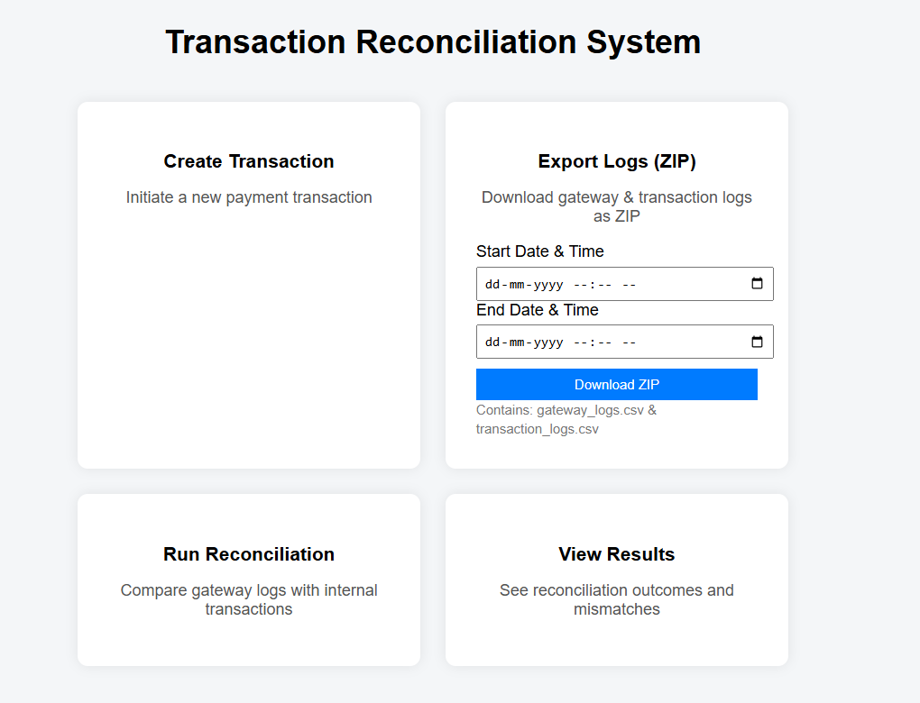
Figure 7.1: Transaction Processing Interface
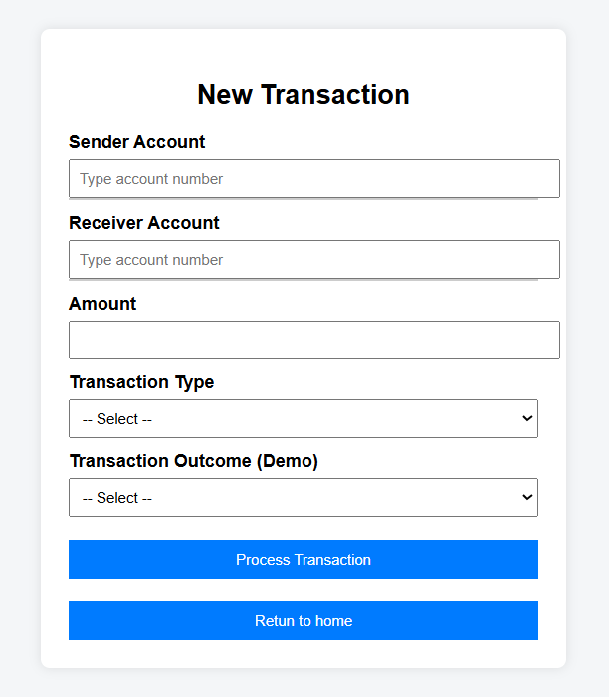
Figure 7.2: New Transaction Processing Page

7.2 RECONCILIATION RESULTS
The Spark-based reconciliation engine successfully compared gateway transaction logs with internal transaction records and classified transactions based on reconciliation conditions.
The reconciliation module successfully detected:
- Matching transactions
- Missing internal records
- Amount mismatches
- Failed transactions
- Out-of-order transactions
- Large-value transactions
The reconciliation outputs were stored in the reconciliation table and displayed through dashboard interfaces for operational monitoring.
The reconciliation workflow improved transaction visibility and reduced the manual effort required for identifying inconsistencies.

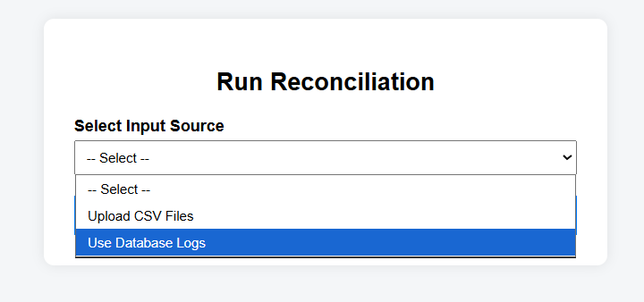
Figure 7.3: Reconciliation Input Selection Interface
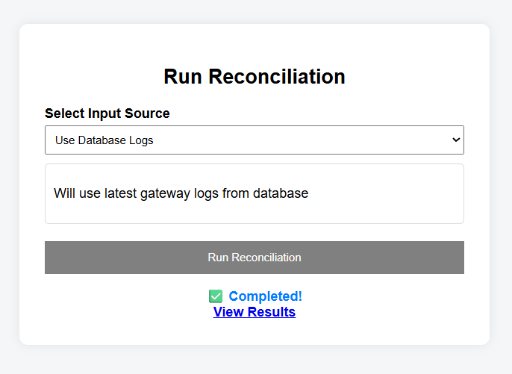
Figure 7.4: Database Reconciliation Processing
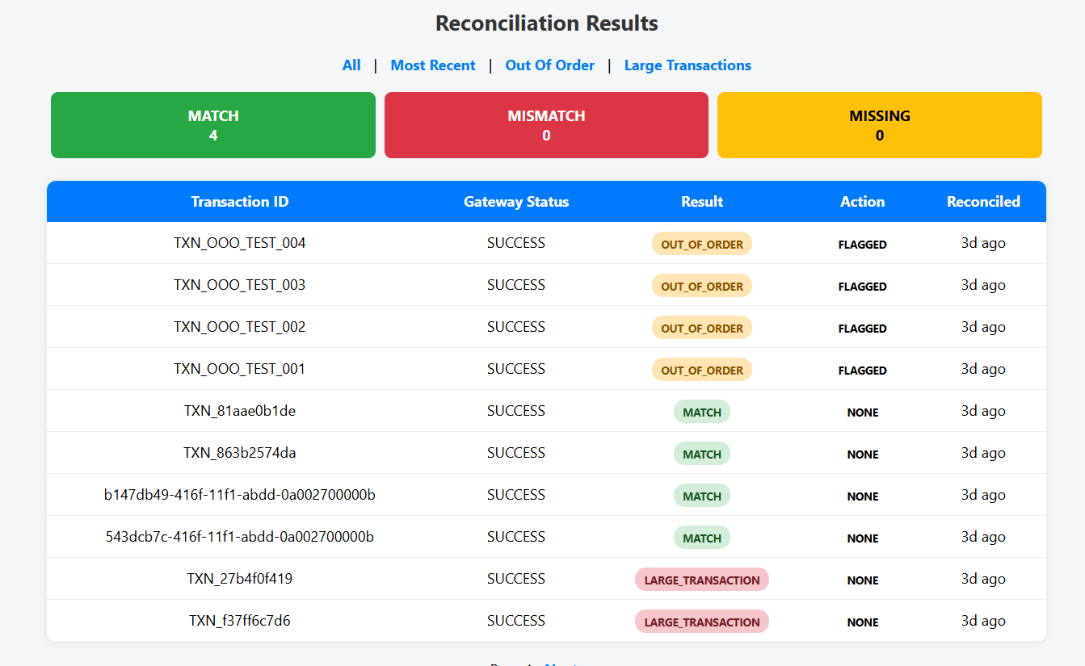
Figure 7.5: Reconciliation Results
7.3 LARGE TRANSACTION ANALYSIS
The large transaction detection module successfully identified transactions exceeding predefined threshold values during reconciliation processing.
Large transactions were:
- Classified separately
- Stored in audit tables
- Displayed through dashboard reports
- Included in analytical summaries
The generated reports helped identify suspicious or high-value transaction activities efficiently.
The audit mechanism improved transaction traceability and operational monitoring within the system.
7.4 OUT-OF-ORDER TRANSACTION ANALYSIS
The out-of-order transaction detection module successfully identified transaction records processed in incorrect timestamp sequences.
Spark window functions and timestamp comparison mechanisms were used to detect:
- Delayed transaction entries
- Incorrect processing sequences
- Gateway synchronization inconsistencies
Detected out-of-order transactions were classified separately and displayed through reconciliation dashboards and analytical reports.
The implementation improved anomaly detection accuracy and transaction monitoring capabilities.
7.5 DASHBOARD AND ANALYTICAL REPORTING
The project successfully generated dashboard-oriented reconciliation reports and analytical transaction summaries. The generated CSV datasets were transformed and prepared for dashboard visualization and operational reporting workflows.
The dashboard provided:
- Reconciliation statistics
- Transaction trends
- Failure analysis
- Rollback monitoring
- Bank-wise transaction analytics
- Large transaction reports
- Out-of-order transaction analysis
The dashboard improved operational visibility and enabled better understanding of transaction processing behavior and reconciliation performance.
The analytical reports also helped in monitoring:
- Transaction failure rates
- Reconciliation consistency
- Processing anomalies
- Transaction distributions
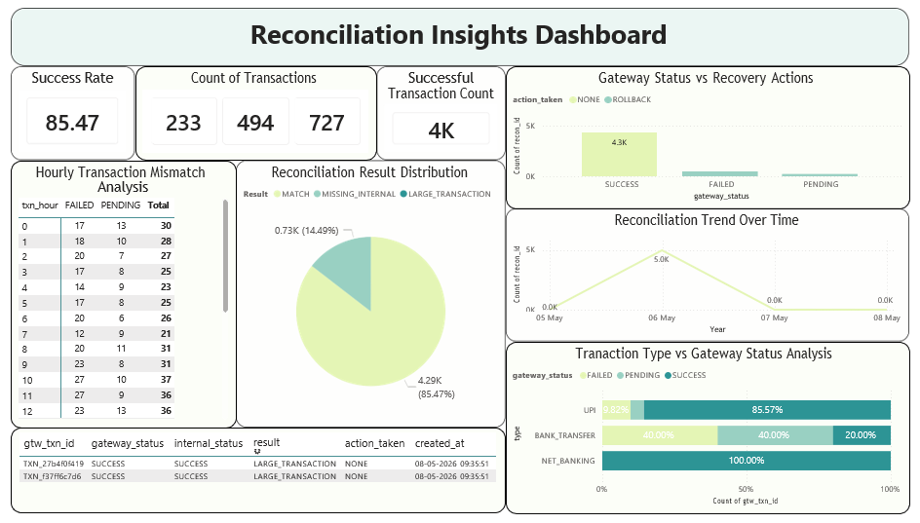
Figure 7.6: Reconciliation Summary Dashboard
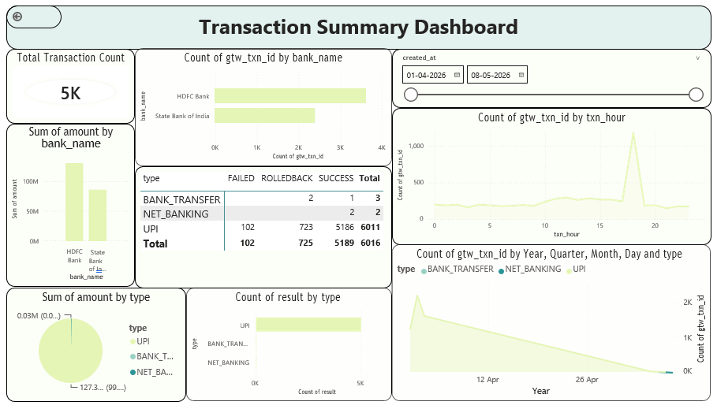
Figure 7.7: Transaction Summary Dashboard

7.6 DISCUSSION
The implemented reconciliation system successfully demonstrated automated transaction reconciliation workflows using Flask, MySQL, and Apache Spark. The project effectively simulated real-world financial transaction monitoring systems used in banking and payment gateway environments.
The use of Apache Spark improved scalability and enabled efficient processing of large transaction datasets. Rollback mechanisms ensured transaction consistency whenever reconciliation mismatches were detected. CSV-based reconciliation workflows improved flexibility and supported external dataset processing.
The project also demonstrated the practical implementation of:
- Transaction monitoring systems
- Distributed data processing
- Analytical reporting
- Reconciliation automation
- Dashboard integration concepts
The internship project provided significant exposure to enterprise application development, backend workflows, scalable processing systems, database management, and operational analytics.
The overall implementation successfully achieved the project objectives related to automated reconciliation, anomaly detection, rollback handling, and dashboard-oriented transaction analysis.

CHAPTER 8
APPLICATIONS

APPLICATIONS
The Transaction Reconciliation System has several applications in financial systems, digital payment infrastructures, banking operations, transaction monitoring platforms, and analytical reporting environments. The project demonstrates how automated reconciliation workflows can improve operational efficiency, transaction visibility, and anomaly detection within enterprise transaction processing systems.
The implemented system can be adapted and extended for multiple real-world applications involving financial transaction monitoring and reconciliation workflows.

8.1 BANKING SYSTEMS
The reconciliation platform can be used in banking environments to compare transaction records between banking applications, payment gateways, and internal ledger systems.
The system helps banks:
- Detect missing transactions
- Identify settlement mismatches
- Monitor transaction consistency
- Automate reconciliation workflows
- Improve operational efficiency
Automated reconciliation reduces manual effort and improves transaction monitoring capabilities within banking infrastructures.
8.2 DIGITAL PAYMENT GATEWAYS
Payment gateway providers process large numbers of transactions daily across multiple systems and platforms. The implemented reconciliation engine can help payment gateway systems identify inconsistencies between gateway records and backend transaction logs.

The project supports:
- Gateway transaction monitoring
- Payment status validation
- Transaction anomaly detection
- Rollback management
- Settlement verification
The system can improve payment reliability and transaction tracking for digital payment infrastructures.

8.3 FRAUD DETECTION AND MONITORING
The project includes features such as:
- Large transaction detection
- Out-of-order transaction monitoring
- Transaction mismatch detection
These features can support suspicious transaction analysis and operational fraud monitoring systems.
The generated reconciliation analytics can help administrators identify:
- Unusual transaction patterns
- High-value financial activities
- Delayed processing events
- Gateway inconsistencies
The system can be extended further using AI/ML-based fraud detection mechanisms in future implementations.

8.4 FINANCIAL AUDITING SYSTEMS
The reconciliation engine can assist financial auditing workflows by maintaining:
- Transaction logs
- Rollback records
- Reconciliation results
- Audit trails
- Analytical transaction reports
Automated reconciliation improves transparency and traceability during financial auditing processes.
The generated reports can help auditors verify:
- Transaction consistency
- Settlement accuracy
- Operational anomalies
- Failed transaction activities

8.5 ENTERPRISE TRANSACTION MONITORING
Large enterprise systems handling distributed transaction workflows can use the reconciliation platform for:
- Operational monitoring
- Batch transaction processing
- Transaction analytics
- Reconciliation reporting
- Error tracking
The dashboard-oriented analytical reports improve operational visibility and support transaction management workflows.
The Spark-based architecture also supports scalable processing for enterprise transaction datasets.
8.6 ANALYTICAL DASHBOARD SYSTEMS
The generated reconciliation outputs and transaction datasets can be integrated with dashboard and business intelligence systems such as Power BI.
The dashboard workflows support:
- Transaction trend analysis
- Failure monitoring
- Reconciliation statistics
- Operational reporting
- Bank-wise transaction analysis
- Large transaction analytics
These analytical dashboards improve decision-making and operational monitoring capabilities for administrators and analysts.

CHAPTER 9
CONCLUSION

CONCLUSION
The Transaction Reconciliation System was successfully designed and implemented during the internship period to automate the process of comparing gateway transaction records with internal transaction logs. The project demonstrated how backend technologies, distributed processing frameworks, and analytical reporting systems can be integrated to improve transaction monitoring and reconciliation workflows within financial systems.
The implemented system successfully performed:
- Automated transaction reconciliation
- Transaction mismatch detection
- Rollback handling
- Large transaction detection
- Out-of-order transaction analysis
- CSV-based reconciliation workflows
- Dashboard-oriented reporting and analytics
The use of Flask and MySQL enabled structured backend development and transaction management, while Apache Spark improved scalability and reconciliation efficiency for large transaction datasets. The project also demonstrated the practical implementation of Spark-based aggregation, window functions, and anomaly detection techniques within reconciliation workflows.
The rollback mechanism improved transaction consistency by restoring account balances whenever reconciliation failures or mismatches were detected. Dashboard-oriented analytical reporting improved operational visibility and enabled transaction trend monitoring, failure analysis, and reconciliation statistics generation.
The project provided valuable practical exposure to:
- Backend application development
- Database management systems
- Distributed data processing
- Financial transaction systems
- Reconciliation workflows
- Dashboard analytics
- Agile Scrum methodology
- Version control and collaborative development
The internship experience significantly improved technical knowledge and problem-solving skills related to enterprise software development and transaction monitoring systems. The project also helped in understanding real-world operational workflows used in banking systems and payment gateway infrastructures.
Overall, the project successfully achieved its objectives related to automated reconciliation, anomaly detection, rollback handling, scalable transaction processing, and analytical dashboard integration while demonstrating the practical application of modern software technologies in financial transaction systems.

CHAPTER 10
FUTURE SCOPE

FUTURE SCOPE
The Transaction Reconciliation System developed during the internship provides a strong foundation for scalable financial transaction monitoring and automated reconciliation workflows. Although the current implementation successfully supports reconciliation, rollback handling, anomaly detection, and dashboard analytics, several enhancements can be implemented in the future to improve scalability, intelligence, automation, and enterprise integration capabilities.
One of the major future enhancements is the implementation of real-time transaction reconciliation using streaming technologies such as Apache Kafka and Spark Streaming. The current system operates using batch-based processing workflows, whereas real-time reconciliation would allow immediate detection of mismatches, failed transactions, and operational anomalies as transactions occur.
The project can also be extended by integrating Artificial Intelligence and Machine Learning techniques for advanced fraud detection and predictive transaction analysis. AI/ML models can help identify suspicious transaction patterns, unusual behavioral trends, and high-risk financial activities automatically using historical reconciliation data.
Future versions of the system may include:
- AI-based anomaly detection
- Predictive fraud monitoring
- Intelligent risk scoring systems
- Automated alert generation
- Real-time transaction analytics
Another important enhancement involves cloud deployment and distributed processing. The current implementation was developed in a local environment, but future implementations can utilize cloud platforms such as AWS, Azure, or Google Cloud for scalable deployment and distributed transaction processing.
The dashboard module can also be improved by integrating advanced business intelligence features such as:
- Interactive Power BI dashboards
- Real-time operational analytics
- Automated reconciliation reports
- Drill-down transaction analysis
- Bank-wise and region-wise analytical visualization
Additional security enhancements such as:
- Data encryption
- Multi-factor authentication
- Role-based access control
- Secure API communication
can be implemented to improve enterprise-level security and compliance.
Future enhancements may also include:
- Mobile application support
- Automated notification systems
- Email and SMS alerts
- API integration with external banking systems
- Multi-gateway transaction processing support
The project demonstrates strong potential for expansion into a full-scale enterprise reconciliation and transaction monitoring platform capable of supporting modern digital banking and financial ecosystems.

CHAPTER 11
REFERENCES

REFERENCES
- Flask Documentation – Python Web Framework
Available at: https://flask.palletsprojects.com/
- Apache Spark Documentation
Available at: https://spark.apache.org/docs/latest/
- MySQL Documentatio
Available at: https://dev.mysql.com/doc/
- Power BI Documentation
Available at: https://learn.microsoft.com/power-bi/
- Agile Scrum Methodology Reference
Available at: https://scrumguides.org/
- Introduction to Enterprise Dashboard – Infosys Lex Learning Platform
Available at: https://lex.infosysapps.com/
- Introduction to PySpark – Infosys Lex Learning Platform
Available at: https://lex.infosysapps.com/
- Big Data 101 – Infosys Lex Learning Platform
Available at: https://lex.infosysapps.com/
- Introduction to Data Lakes – Infosys Lex Learning Platform
Available at: https://lex.infosysapps.com/
- Introduction to Business Intelligence – Infosys Lex Learning Platform
Available at: https://lex.infosysapps.com/
- Multidimensional Data Modeling – Infosys Lex Learning Platform
Available at: https://lex.infosysapps.com/
- Introduction to Data Warehouse – Infosys Lex Learning Platform
Available at: https://lex.infosysapps.com/
- Programming and OOP using Java – Infosys Lex Learning Platform
Available at: https://lex.infosysapps.com/
- Financial Transaction Reconciliation Concepts
International Journal of Financial Systems and Transaction Processing
- Database Management System Concepts
Abraham Silberschatz, Henry F. Korth, S. Sudarshan

- Big Data Processing using Apache Spark
Holden Karau, Andy Konwinski, Patrick Wendell, Matei Zaharia
- Power BI Dashboard and Visualization Concepts
Business Intelligence and Reporting Documentation

Internship / Group Photographs


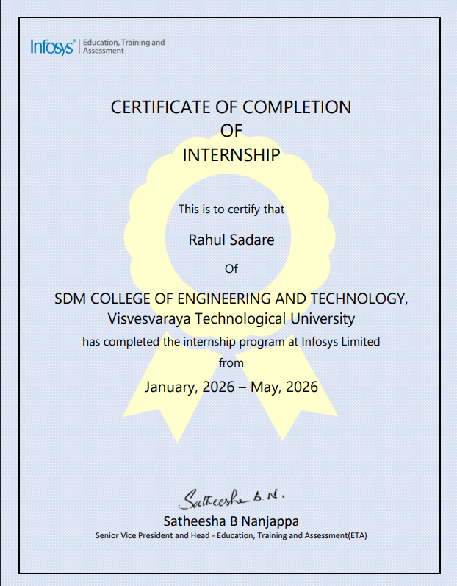
Internship Completion Certificate

